**ASD Part 1**

Group 2

Group members:

**William Forber Id: 22015706**

**Zahin Hussain Id: 22016373**

**Lewis Quick Id: 22016949**

**Tawfiq Esawy Id: 21017418**

**Beyzanur Kayaci Id: 22066921**

**Requirements Analysis:**

The restaurant needs to have the following functionalities:

* Order Management
  + CRUD orders.
    - Customer, items, eat-in/delivery.
  + Order status, on what stage the order is at.
* Inventory Management
  + CRUD stock.
* Reservation Management
  + CRUD reservations.
    - Check the required seats before booking at a specified time.
    - Make a reservation number with the table number.
* Menu management
  + CRUD dishes on the menu.
* Offer management.
  + CRUD offers.
    - Different offers for specific dishes
* Generate reports.
  + Sales
  + Inventories (stocks)
  + Item / dish preparation times

**Use Case Diagram:**

**William Forber, Zahin Hussain, Lewis Quick, Tawfiq Esawy , Beyzanur Kayaci**

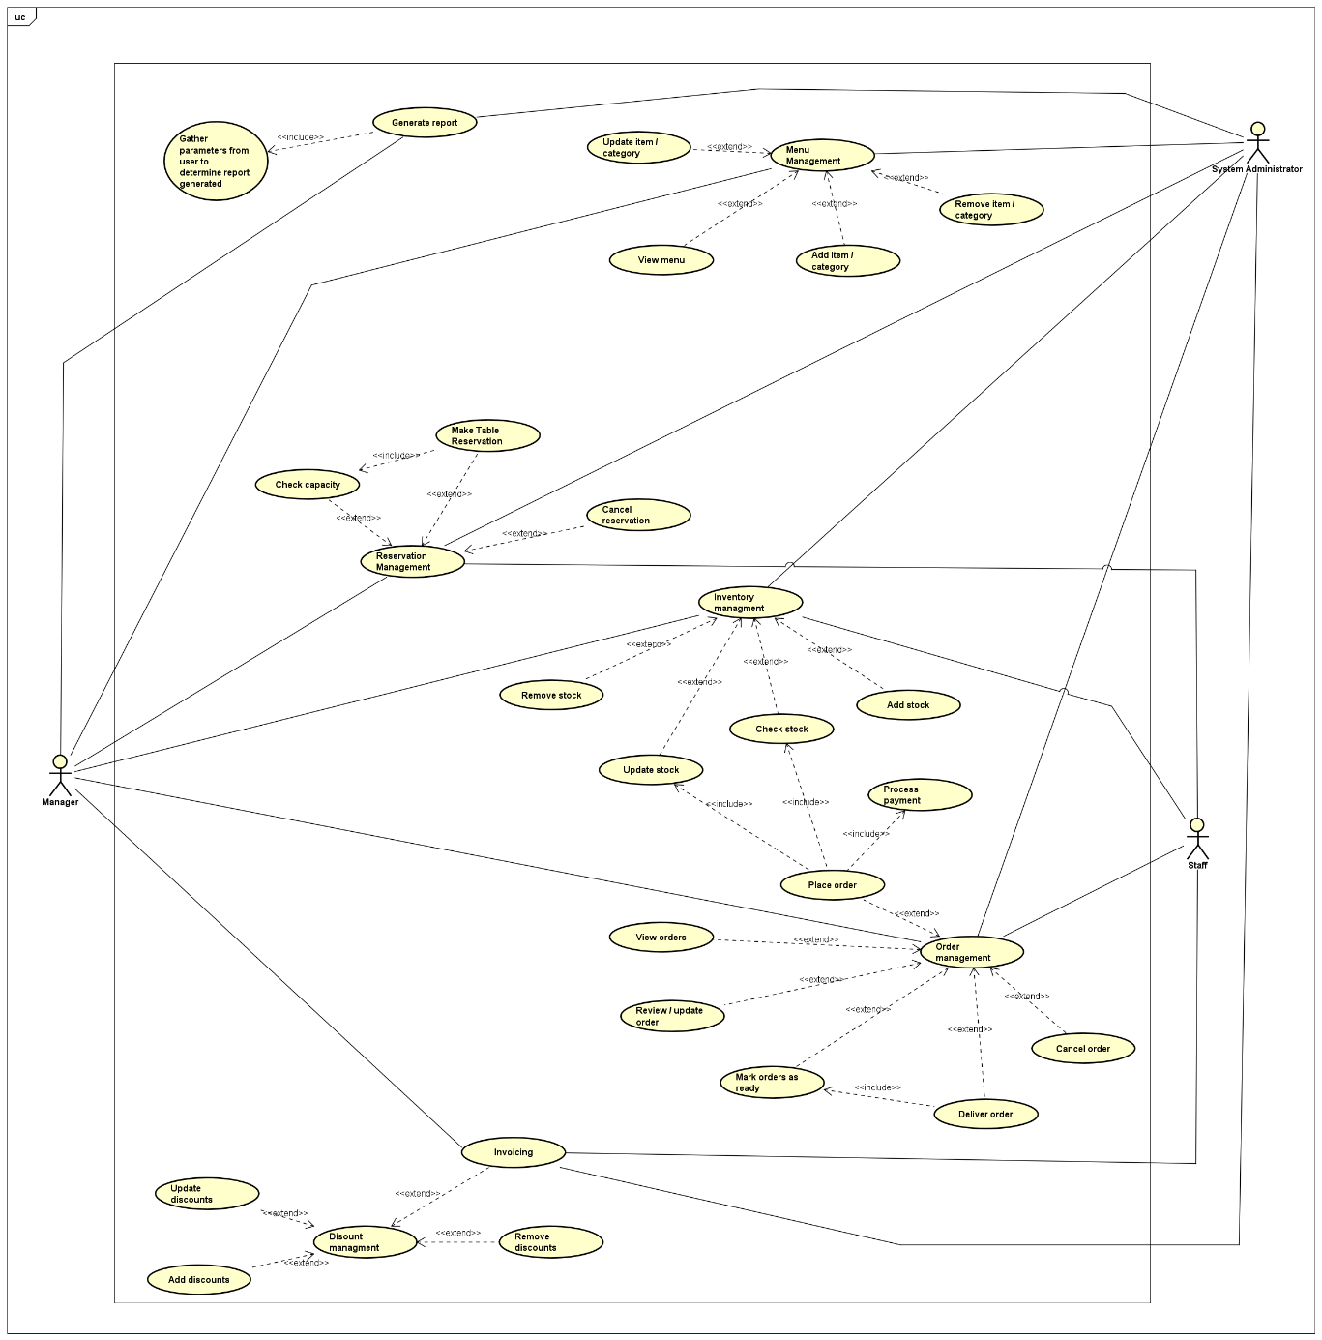

**Class Diagram:**

**William Forber, Zahin Hussain, Lewis Quick, Tawfiq Esawy , Beyzanur Kayaci**

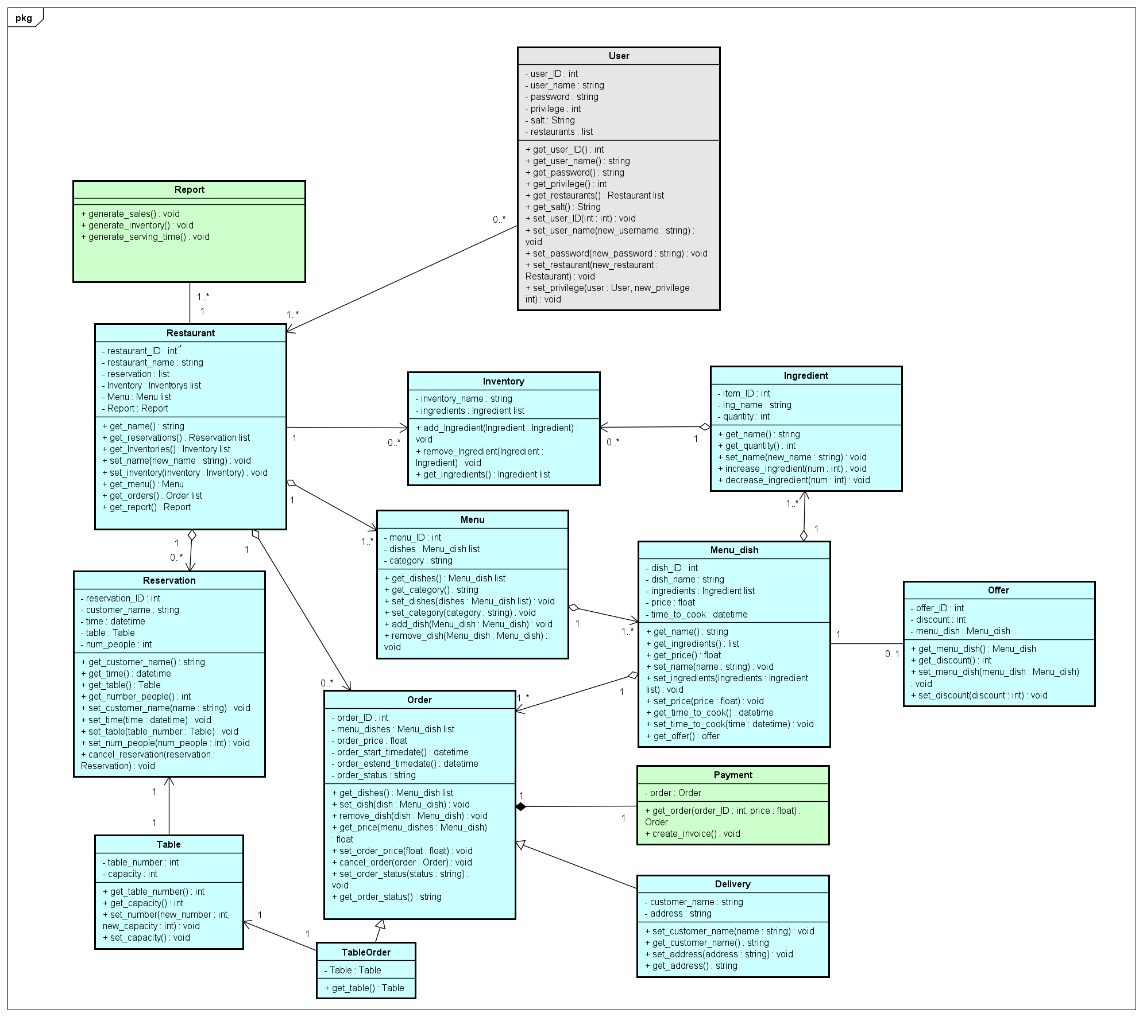

**Sequence Diagrams:**

Add a dish to the menu:

**Lewis Quick**

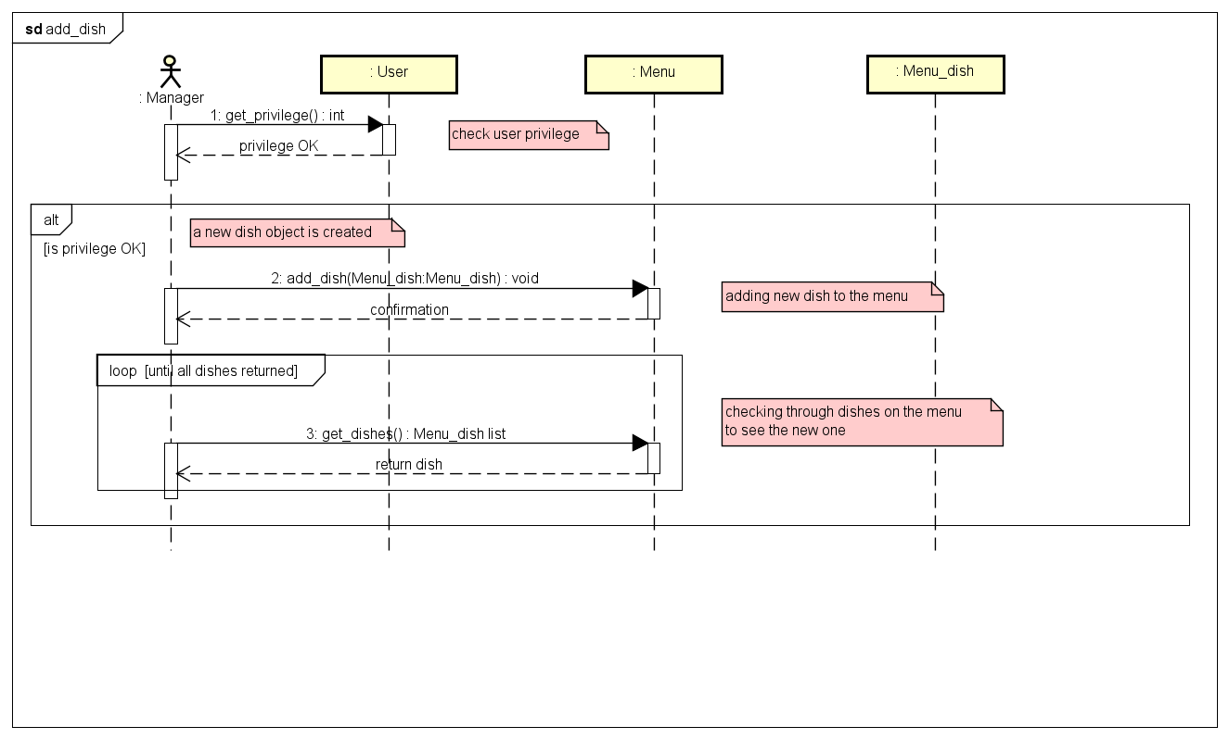

Get capacity of restaurant:

**Beyzanur Kayaci**

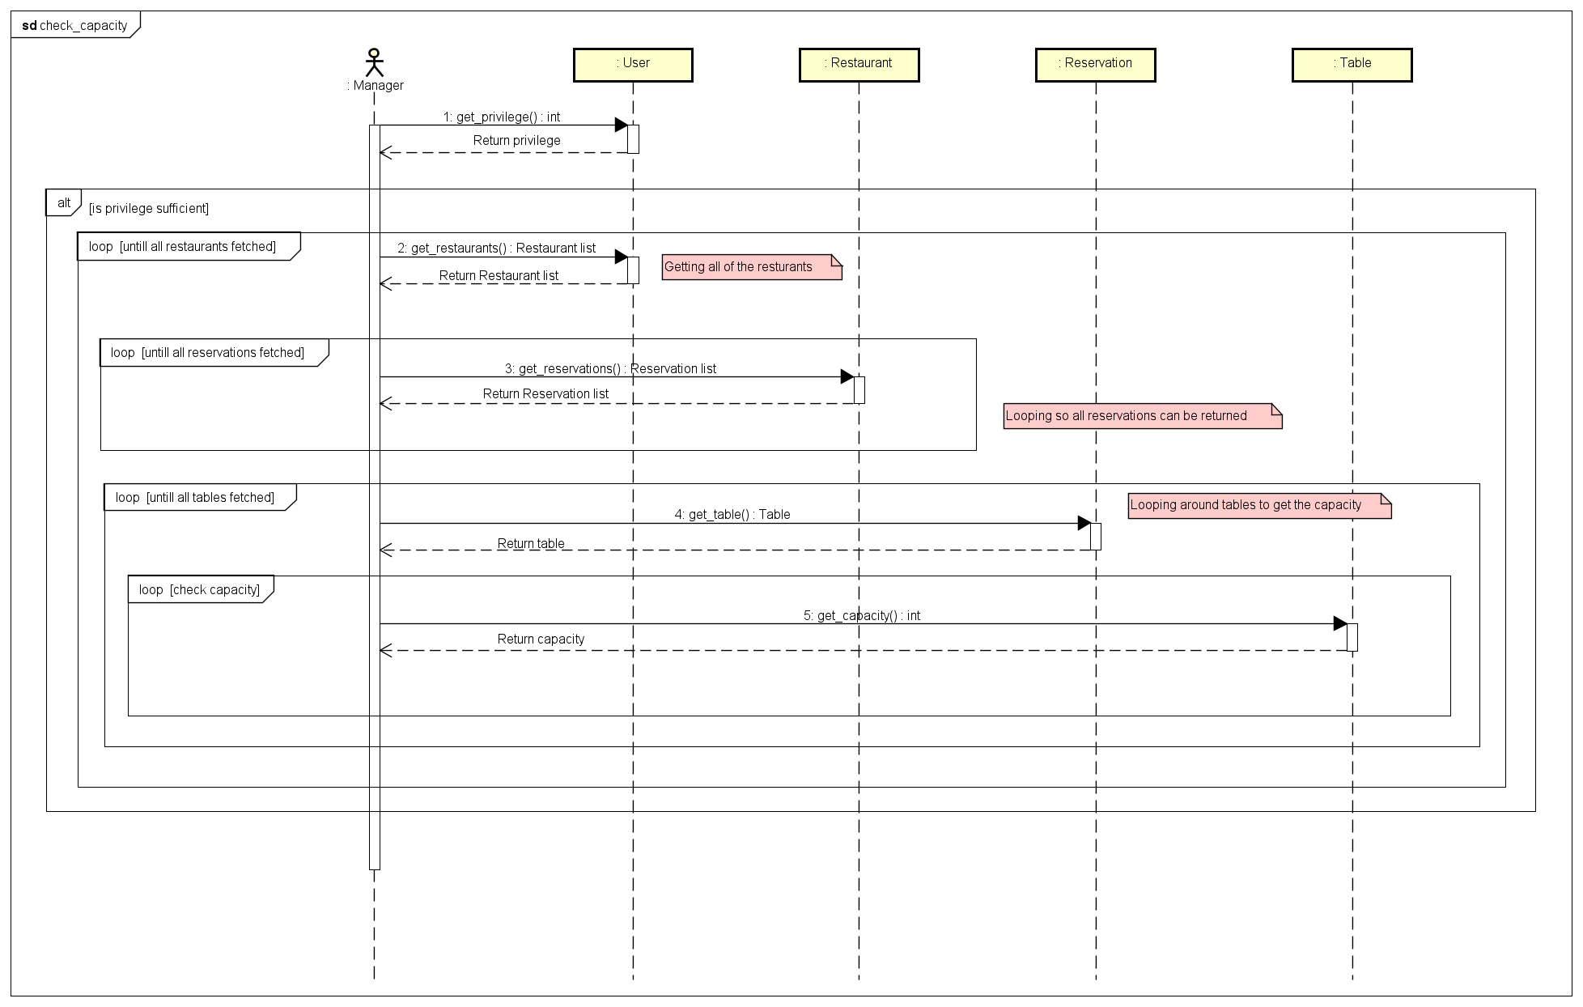

Cancel Order:

**Zahin Hussain**

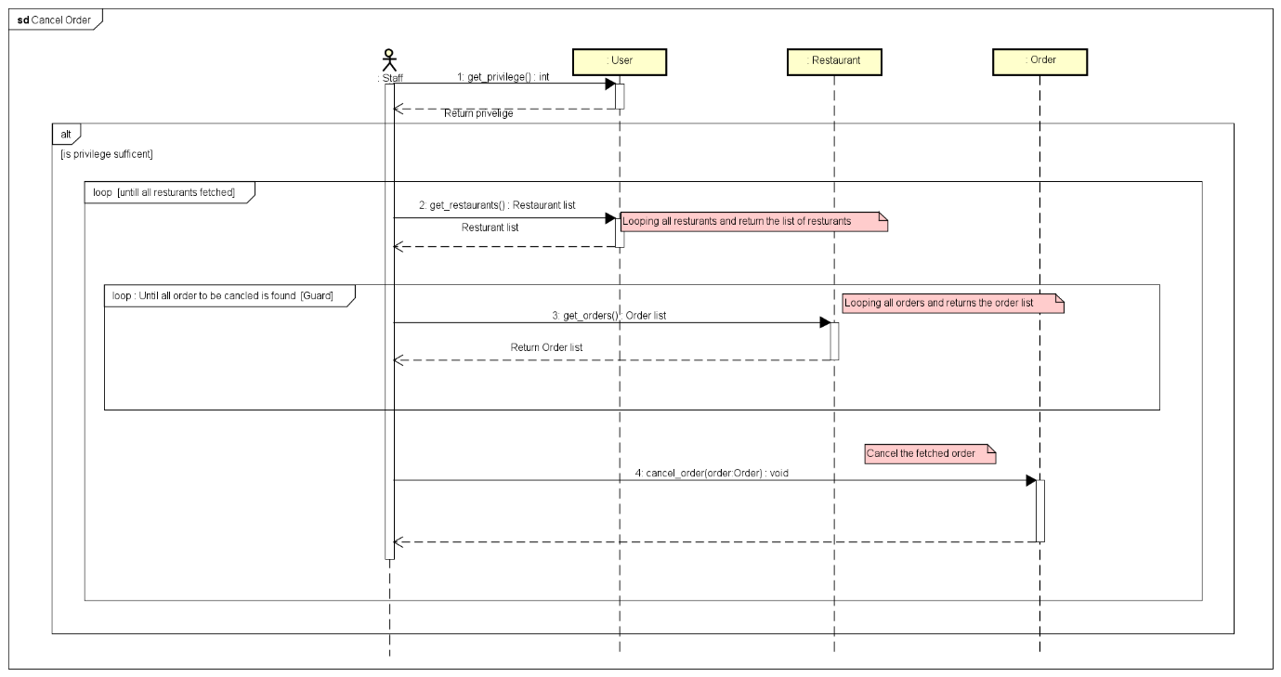

Check stock:

**William Forber**

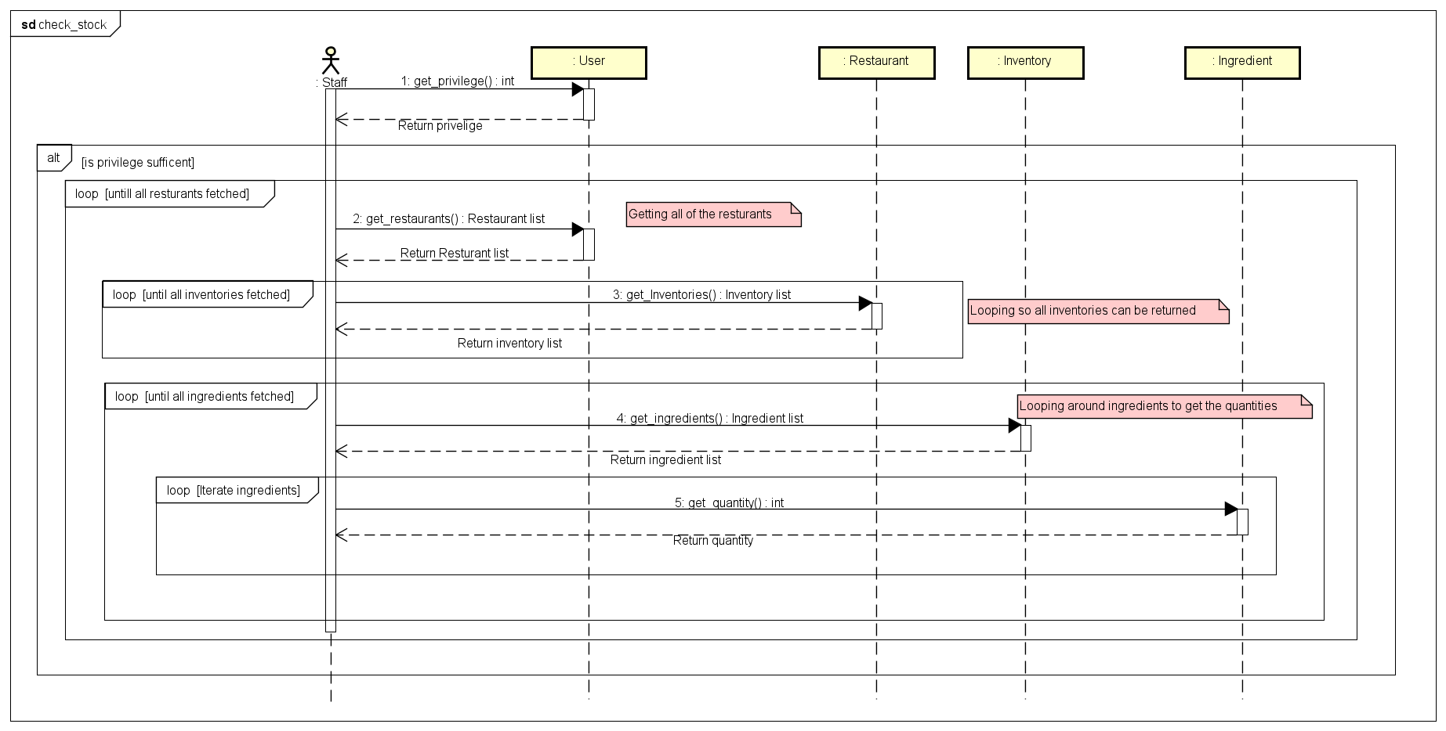

Generate reports:

**Tawfiq Esawy**

